CSC387 Lab 03 – Multi Area OSPF

# Verification Steps

1. 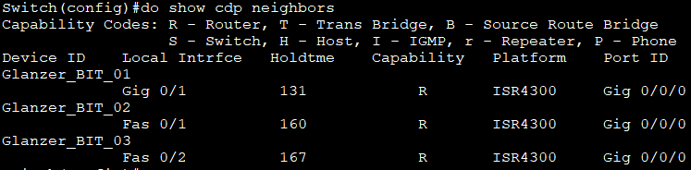From router BIT_01, when you run the **show neighbors command**, you should see both routers BIT_02 and BIT_03 listed in the output.
2. 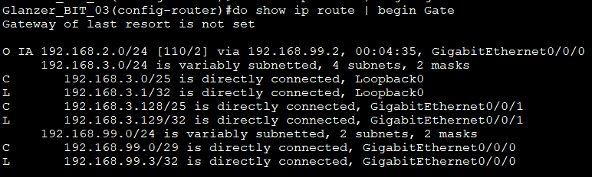On router BIT_03 run a **show ip route** and look at the routing table. You will see networks that belong to router BIT_02 (**192.168.2.0/25** and **192.168.2.128/25**).

I believe it is showing 192.168.2.0/24 because I added the summarization for area 2 (which contains both subnets represented by the 25th bit) so BIT_3 recognizes it as a single /24 link instead of two /25s

1. From router BIT_03, run a **show ip ospf neighbor** and you should see the other routers in the output. Neighbor ID column will show the router IDs that you set. BIT_01 Should be a DR and BIT_02 will be a BDR. 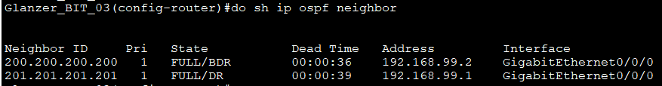
2. On routerBIT_01, turn on OSPF debugging (**debug ip ospf packet**) and look for a hello packet. Remember, in a point-to-point network, these will happen every 10 seconds or so. Looks like this command has been changed to events instead of packet

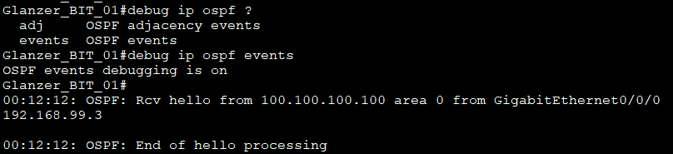

1. Once everything is configured, you should be able to ping from Laptop 1 to BIT_03’s

loopback adapter.

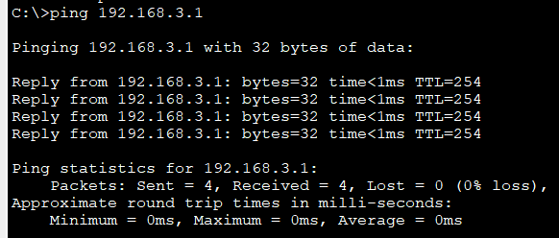

# What to Turn In

Go through each of the verification steps and take a screenshot. Please try to show each step in a single, clear screenshot to cut down the number of images. Also, paste all screenshots into a single Word/PDF document. Do not upload them to D2L as individual images – I won’t grade them.